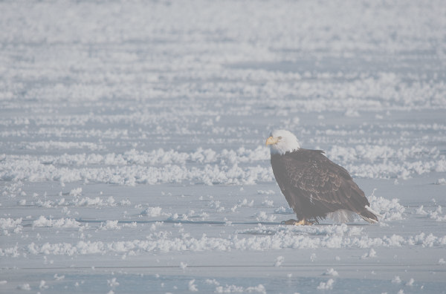
3rd Annual Spirit of EAGLES
American Indian/Alaska Native
Leadership Initiative on Cancer
Southeastern Alliance Conference
March 22 & 23rd 2006
Wilmington, North Carolina

The Spirit and The Sea

ELIMINATING CANCER DISPARITIES IN
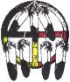
INDIAN COUNTRY
¤
BACK TO INDIVIDUALS, FAMILIES, AND COMMUNITIES

HOSTED and Sponsored by the
Mayo Clinic Spirit of EAGLES
funded by NCI
The North Carolina Commission on
Indian Affairs
and,
Men Against Breast Cancer, Inc.

