www.minority.unc.edu
Summer Public Health Research Videoconference on Minority Health
JUNE 12-16, 2000; 1:30-4:30pm EDT
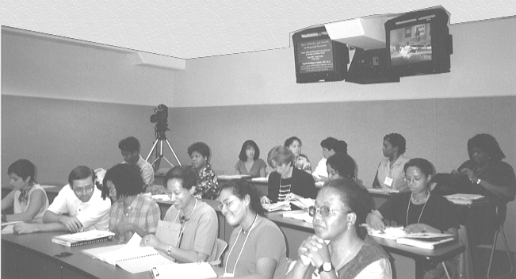
This annual Videoconference covers issues and solutions related to: collecting, analyzing and interpreting data for racial/ethnic populations; disentangling and assessing the relationships among race, ethnicity, and socioeconomic status; and involving the community in research. Videoconference participants can ask questions and join discussions via toll-free telephone, fax, and e-mail.
To obtain information or register as a Videoconference site, visit: http://www.minority.unc.edu or send your questions to Minority_Health@unc.edu Please note that there is no site fee this year.
Presented by the University of North Carolina at Chapel Hill, School of Public Health (Dean's Office, Center for Health Statistics Research, and Department of Maternal and Child Health), in collaboration with the CDC National Center for Health Statistics and the Association of Schools of Public Health

Participating downlink sites in most states – see www.minority.unc.edu
Please see other side for Agenda and Speakers
2000 Summer Public Health Research Videoconference on Minority Health
Videoconference agenda
(All sessions begin at 1:30 pm EDT and end at 4:30 pm EDT, with one 15-minute break.)

MONDAY, June 12, 2000 - Eliminating health disparities
John Ruffin, Ph.D., Associate Director
Office of Research on Minority Health, National Institutes of Health
Linda Burhansstipanov, Dr.P.H., Keynote
Director, Native American Cancer Research Program
TUESDAY, June 13, 2000 - Measurement and classification in the 2000 census
Camara P. Jones, M.D., Ph.D.
Assistant Professor, Department of Health & Social Behavior, Harvard School of Public Health
Olivia D. Carter-Pokras, M.H.S., Ph.D.
Division Director, Division of Policy and Data, Office of Minority Health, DHHS
WEDNESDAY, June 14, 2000 - Counting and sampling ethnic minorities
William D. Kalsbeek, Ph.D.
Professor, Department of Biostatistics, UNC School of Public Health
Elena Yu, Ph.D.
Professor, Department of Epidemiology and Biostatistics,
Graduate School of Public Health, San Diego State University
THURSDAY, June 15, 2000 - Cognition and culture
Richard B. Warnecke, PhD
Director and Professor, Center for Health Services Research and Health Policy
Departments of Sociology, Epidemiology and Biometry, University of Illinois at Chicago
Aida L. M. Giachello, Ph.D.
Director and Associate Professor, Midwest Latino Health Research, Training, and Policy Center
Jane Addams College of Social Work, University of Illinois at Chicago
FRIDAY, June 16, 2000 - Community-based Research
Robert E. Fullilove, III, Ed.D.
Associate Professor and Associate Dean of Community and Minority Affairs
The Joseph L. Mailman School of Public Health, Columbia University
Barbara A. Israel, Dr.P.H.
Professor, Department of Health Behavior and Health Education
University of Michigan School of Public Health

www.minority.unc.edu

5/11/2000

