2000 Summer Public Health Research Videoconference on Minority Health

MONDAY, June 12 - Eliminating health disparities
Moderator: Miriam Thomas
Co-anchor for News Channel 11, Durham NC
1:30pm Introduction to the 2000 Summer Public Health Research Videoconference on Minority Health
1:45pm Framework for Understanding Health Disparities
John Ruffin, Ph.D.
Associate Director for Research on Minority Health, NIH
2:35pm Questions and discussion
2:50pm Break
3:05pm Keynote Address: Native American Health Issues: Lessons Learned from Community-Based Interventions, and Overview of Native Cancer Projects
Linda Burhansstipanov, M.S.P.H., Dr.P.H., C.H.E.S.
Executive Director, Native American Cancer Research Program
4:05pm Questions and discussion
4:20pm Closing remarks

TUESDAY, June 13 - Conceptualization and measurement of race
and ethnicity
Moderator: Marian Johnson-Thompson, Ph.D.
Director, Education and Biomedical Research Development
1:30pm The Impacts of Racism on Health
Camara P. Jones, M.D., M.P.H., Ph.D.
Assistant. Professor, Dept. of Health & Social Behavior, Harvard School of Public Health
2:30pm Questions and discussion
2:50pm Break
3:05pm Olivia D. Carter-Pokras, M.H.S., Ph.D.
Division Director, Div. of Policy and Data, Office of Minority Health, DHHS
4:05pm Questions and discussion
4:20pm Closing remarks

WEDNESDAY, June 14 - Surveying ethnic populations
Moderator: Victor J. Schoenbach, Ph.D.
Associate Professor, UNC Dept. of Epidemiology, Co-Principal Investigator, Minority Health Project
1:30pm Sampling Racial and Ethnic Minorities
William D. Kalsbeek, Ph.D.
Professor, Department of Biostatistics
Director, Center for Health Statistics Research, UNC School of Public Health
3:05pm Minority Health Research: Application of Epidemiologic Methods
Elena E. S. Yu, Ph.D.
Professor, Department of Epidemiology and Biostatistics, Graduate School of Public Health, San Diego State University
4:05pm Questions and discussion
4:20pm Closing remarks

THURSDAY, June 15 - Cognition and culture
Moderator: Trude A. Bennett, Dr.P.H.
Associate Professor, UNC Department Maternal and Child Health, Co-Principal Investigator, Minority Health Project
1:30pm Qualitative Approaches to Questionnaire Design: Methods and Applications
Richard B. Warnecke, Ph.D.
Director, Health Policy Center & Center for Health Services Research, Professor, Dept. of Sociology, Epidemiology & Biometry, University of Illinois at Chicago
2:30pm Questions and discussion
2:50pm Break
3:05pm Issues and Challenges in Reducing Health Disparities among Hispanics/Latinos in the U.S.
Aida L. M. Giachello, Ph.D.
Director, Midwest Latino Health Research, Training, & Policy Center, Associate Professor, Jane Addams College of Social Work, University of Illinois at Chicago
4:05pm Questions and discussion
4:20pm Closing remarks

FRIDAY, June 16 - Community-based Research
Moderators: Dorothy C. Browne, M.S.W., Dr.P.H.
Associate Professor, UNC Dept. of Maternal and Child Health, Co-Principal Investigator, Minority Health Project;
Audrey S. Burwell, M.S.
Director, Minority Grants Program, National Center for Health Statistics/CDC
1:30pm Assumptions in Community-based Research and Assessment
Robert E. Fullilove, III, Ed.D.
Associate Professor and Associate Dean of Community and Minority Affairs, The Joseph L. Mailman School of Public Health, Columbia University
2:30pm Questions and discussion
2:50pm Break
3:05pm The Detroit Community Academic Urban Research Center: Principles, Rationale, Challenges and Lessons Learned through a Community-Based Participatory Research Partnership
Barbara A. Israel, Dr.P.H.
Professor, Dept. of Health Behavior and Health Education University of Michigan School of Public Health
4:05pm Questions and discussion (recorded from the morning)
4:20pm Closing remarks
Credits and acknowledgements:

Videoconference Director
Victor J. Schoenbach, Ph.D.
Planning Committee
Trude A. Bennett, Dr.P.H.
Dorothy C. Browne, M.S.W., Dr.P.H.
Victor J. Schoenbach, Ph.D.
Project Coordinator
Millicent Ellison Brown, Ph.D.
Project Assistant
Kenitra Carby-Shields
Graduate Assistants
Kyna K. McCullough
Monica Perez-Jolles
Project Secretary
Patricia Burnette
Video production
Lewis E. Binkowski
Martin Melvin
Computer Support
Jeno M. Bratts
Matthew Mielke
Thomas P. Morris
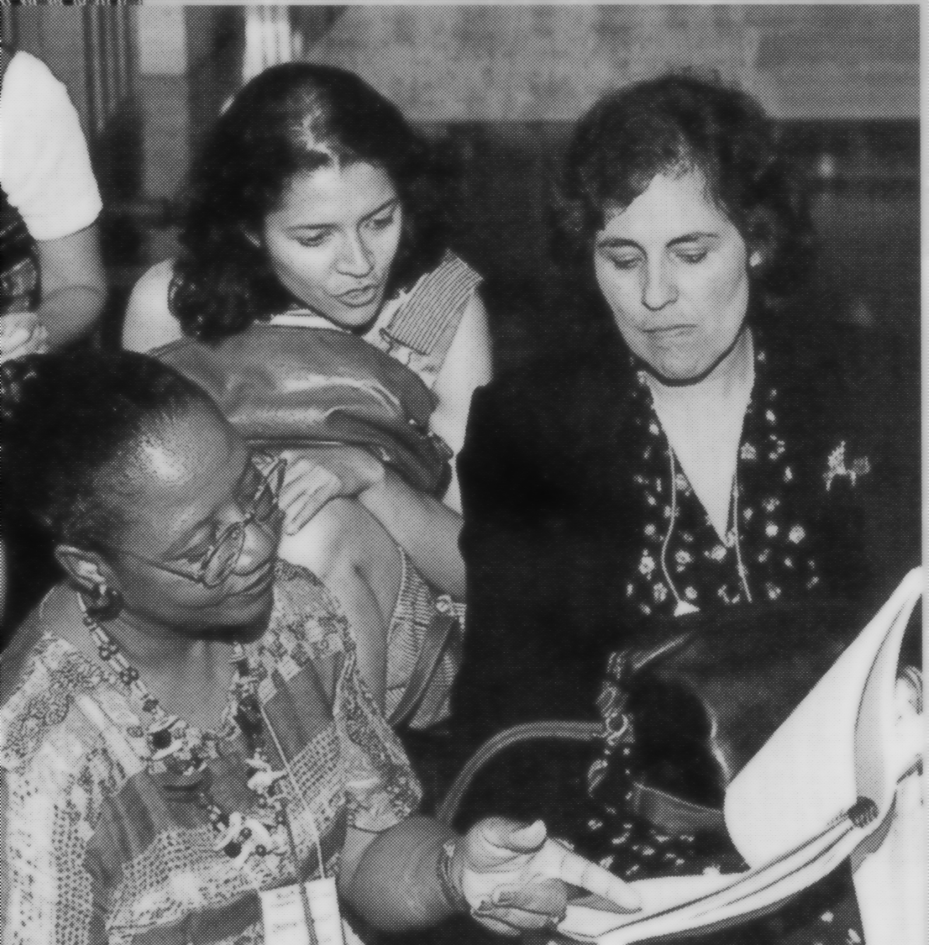
Graphics Design
Kimberly McClain
Videoconference Sites
Site facilitators and technical coordinators
Sponsorship
UNC School of Public Health
William L. Roper, M.D., M.P.H., Dean
Dean's Office
Center for Distance Learning and Health Communications
Department of Biostatistics
Center for Health Statistics Research
William D. Kalsbeek, Ph.D., Principal Investigator
(CDC National Center for Health Statistics, contract No. UR6/CCU417428-01)
UNC Department of Maternal and Child Health
Pierre Buekens, M.D., M.P.H., Chair
Minority Grants Program
Audrey S. Burwell, Director
CDC National Center for Health Statistics

www.minority.unc.edu

Summer Public Health Research Videoconference on Minority Health

JUNE 12-16, 2000
1:30-4:30pm
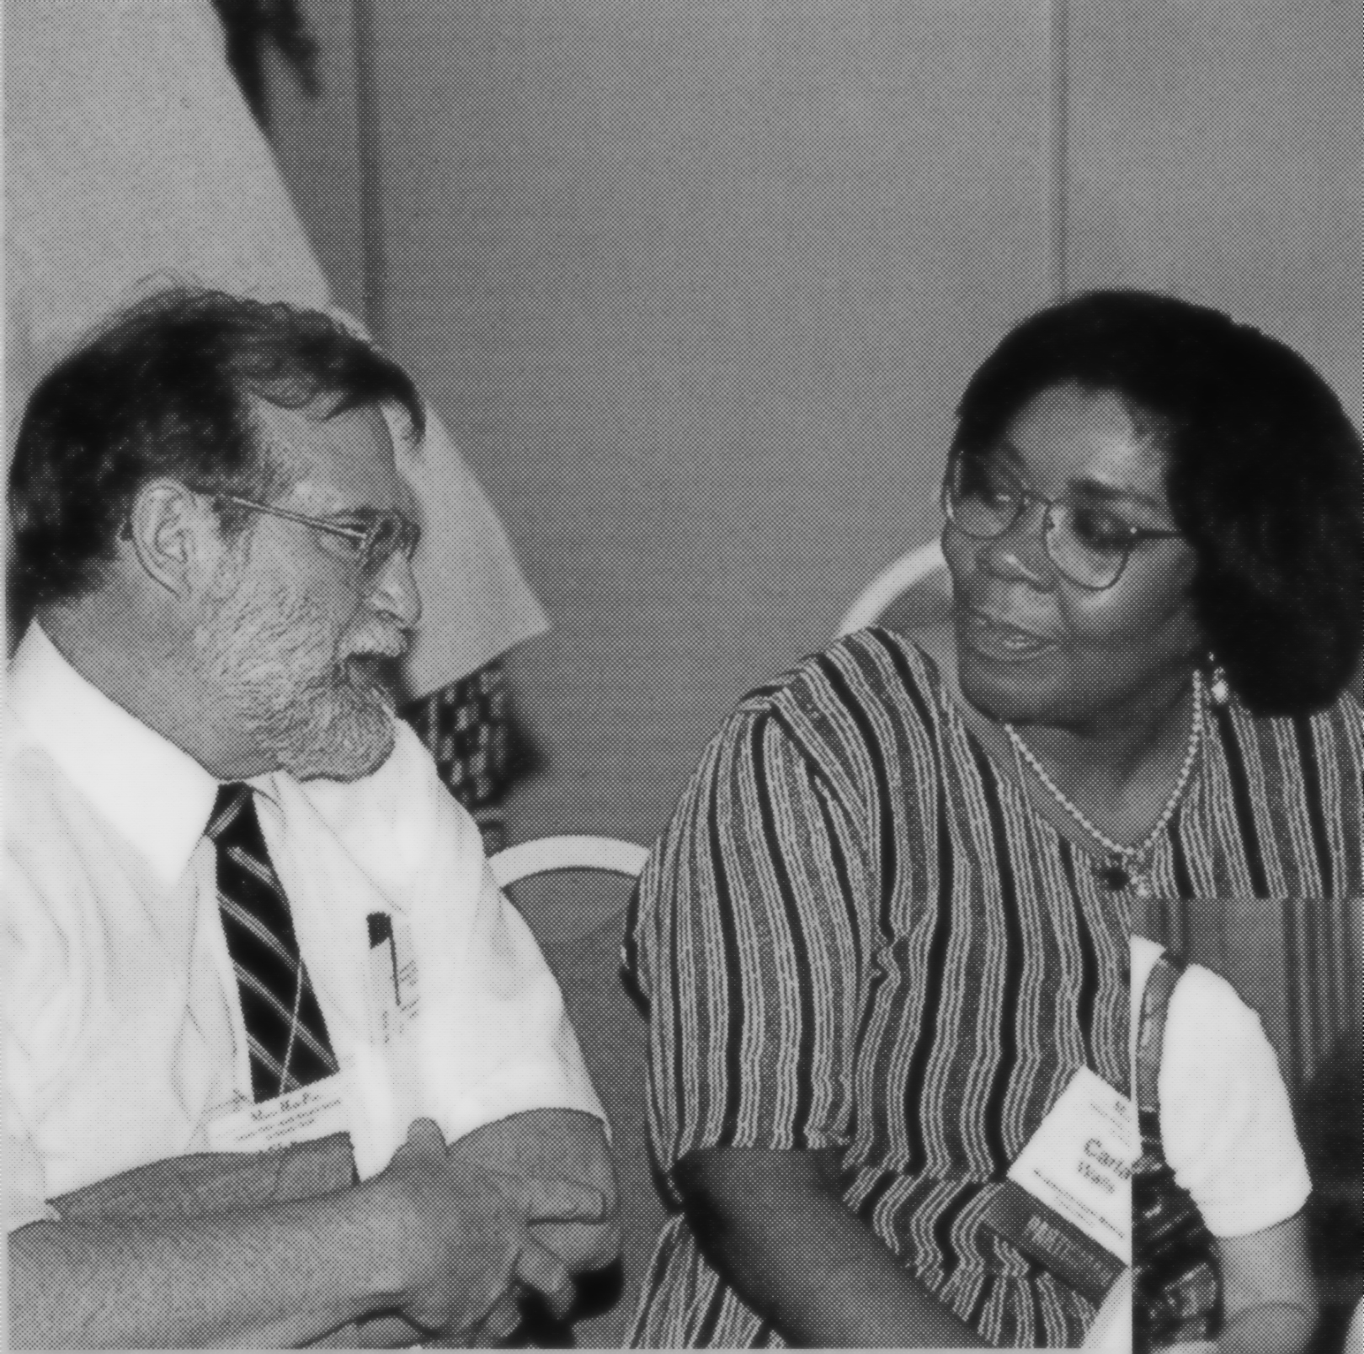
Presented by the University of North Carolina at Chapel Hill, School of Public Health (Dean's Office, Center for Health Statistics Research, and Department of Maternal and Child Health), in collaboration with the CDC National Center for Health Statistics and the Association of Schools of Public Health

