Summer Public Health Research Videoconference on Minority Health
JUNE 18-22, 2001; 1:30-4:30pm EDT
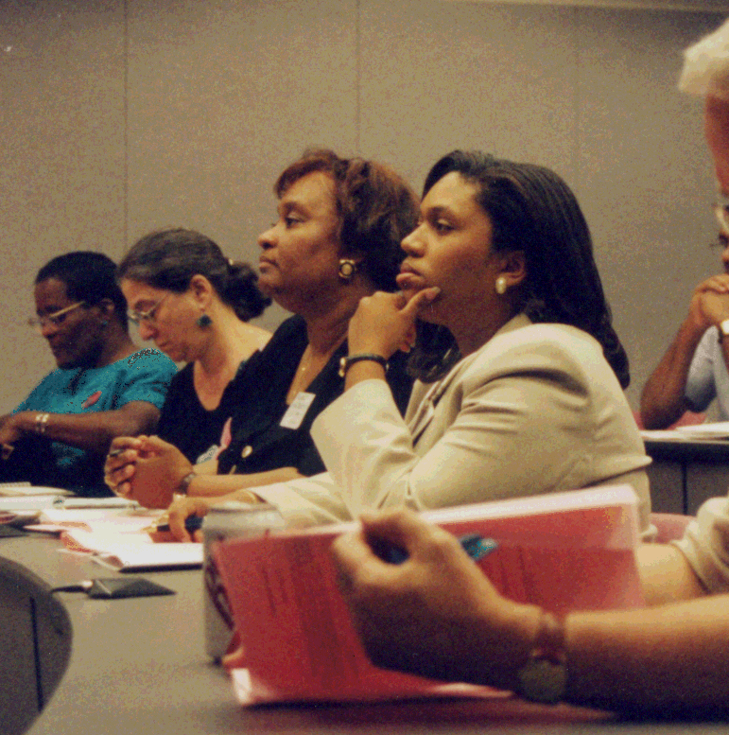

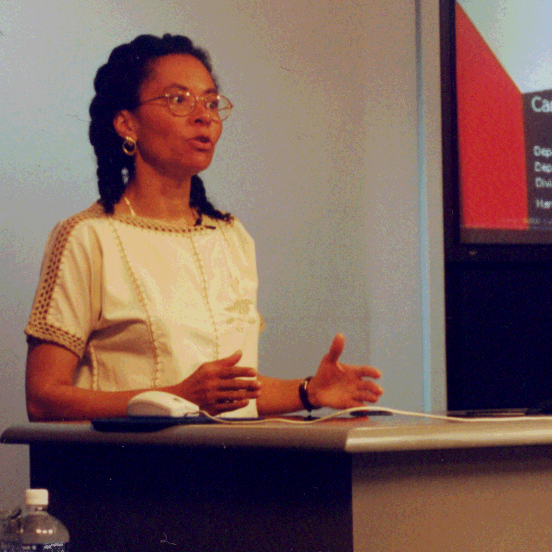


This annual Videoconference covers issues and solutions related to: collecting, analyzing and interpreting data for racial/ethnic populations; disentangling and assessing the relationships among race, ethnicity, and socioeconomic status; using ethnographic research to improve enumeration and data quality; and community-academic research partnerships. Videoconference participants ask questions and join discussions via toll-free telephone, fax and/or email.

PLEASE SEE REVERSE SIDE FOR AGENDA AND SPEAKERS.

www.minority.unc.edu
2001 Summer Public Health Research
Videoconference on Minority Health

Videoconference Agenda
(All sessions begin at 1:30 pm EDT and end at 4:30 pm EDT, with one 15-minute break)

MONDAY, June 18, 2001
Research in Diverse Communities: Towards the Elimination of Disparities

William D. Hobson, Associate Administrator
Bureau of Primary Care, Health Resources and Services

Camara P. Jones, M.D., M.P.H., Ph.D. (Keynote)
Research Director on Social Determinants of Health, National Center for Chronic Disease Prevention and Health Promotion, Centers for Disease Control and Prevention

TUESDAY, June 19, 2001
Defining and enumerating diverse populations - conceptual issues and ethnographic approaches

Manuel de la Puente, Ph.D.
Assistant Division Chief for Survey Methodology, Bureau of the Census

Olivia D. Carter-Pokras, M.H.S., Ph.D.
Division Director, Division of Policy and Data, Office of Minority Health, DHHS

WEDNESDAY, June 20, 2001
Issues for the 21st Century: Health Issues Confronting American Indians and Counting Ethnic Minorities

Felicia Schanche Hodge, Dr.P.H.
Professor/Director, School of Nursing, University of Minnesota, CAIRE Center

Glenn D. Magpantay, Esq.
Democracy Project Director, Asian American Legal Defense and Education Fund

THURSDAY, June 21, 2001
Principles for Appropriate Academic Research Partnerships

Aida L. M. Giachello, Ph.D.,
Director, Midwest Latino Health Research, Training, and Policy Center
Associate Professor, Jane Addams College of Social Work, University of Illinois at Chicago

Margaret A. Davis, R.N., M.S.N., F.N.P.
Director of the Office of Community Health, Healthcare Consortium of Illinois

FRIDAY, June 22, 2001
Effective Community and University Partnerships for HIV/AIDS Research: What Works and Why?

Ralph J. DiClemente, M.S., Ph.D.
Charles Howard Candler Professor of Public Health, Emory University

Gina M. Wingood, M.P.H., Sc.D.
Assistant Professor, Emory University

Linda Felix
Peer Educator, The WILLOW Program, Emory University 05/15/2001

