12th Annual Summer Public Health Research Videoconference on Minority Health

June 26: “Examining the Science Behind Race-Specific Medicine”

June 28: “Tobacco Use Prevention Initiatives at Historically Black Colleges and Universities”
Program begins at 2:00pm EDT (11:00am PDT, 12:00pm MDT, 1:00pm CDT)
The Videoconference is broadcast via satellite and Internet.

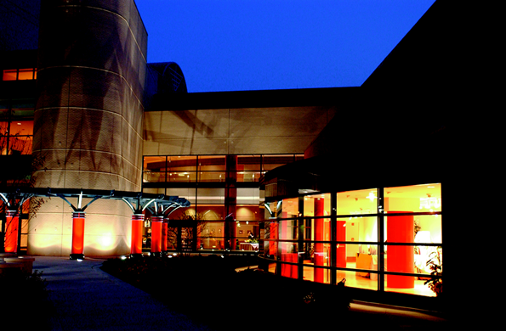
June 26: Sonja Haynes Stone Center for  Black Culture and History, UNC-CH | June 28: Morgan State University  Carl J. Murphy Fine Arts Center

Presented by the
Minority Health Project (UNC Program on Ethnicity, Culture, and Health Outcomes)
and the Center for Health Disparities Solutions at Morgan State University
Major sponsors
Centers for Disease Control and Prevention (NCHSTP/ASPH)
UNC-CH School of Public Health Dean’s Office
Center for Health Disparities Solutions at Morgan State University
American Legacy Foundation


www.minority.unc.edu

