12th Annual Summer Public Health Research Videoconference on Minority Health

June 26: “Examining the Science Behind Race-Specific Medicine”
Attend the live event at the Sonja Haynes Stone Center or watch the webcast.

June 28: “Tobacco Use Prevention Initiatives at Historically Black Colleges and Universities”

View the live Internet broadcast at the Michael Hooker Research Center.

Program begins at 2:00pm EDT on both days.

 | 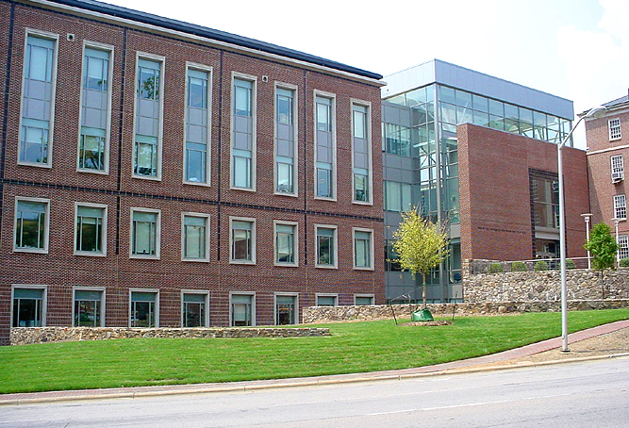
Monday: Sonja Haynes Stone Center for  Black Culture and History, UNC-CH | Wednesday: Michael Hooker Research Center,  School of Public Health, UNC-CH

Presented by the
Minority Health Project (UNC Program on Ethnicity, Culture, and Health Outcomes)
and the Center for Health Disparities Solutions at Morgan State University
Major sponsors
Centers for Disease Control and Prevention (CDC)
UNC-CH School of Public Health Dean’s Office
Center for Health Disparities Solutions at Morgan State University
American Legacy Foundation


www.minority.unc.edu

