13th Annual Summer Public Health Research Videoconference on Minority Health

Does Racism Make Us Sick?

Satellite and Internet broadcast from the UNC-CH
Sonja Haynes Stone Center for Black Culture and History
June 25, 2007, 2:00pm-4:00pm EDT (11:00am PDT, 12:00pm MDT, 1:00pm CDT)

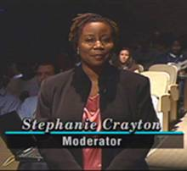 | 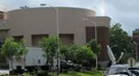 | 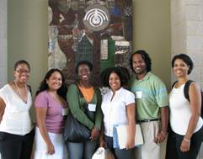
 | 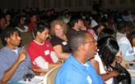

Featured speakers
Luisa N. Borrell, D.D.S., M.P.H., Ph.D.
Gilbert C. Gee, Ph.D.
Karina Walters, M.S.W., Ph.D.
David R. Williams, Ph.D.
Presented by the
Minority Health Project (UNC Program on Ethnicity, Culture, and Health Outcomes) and the UNC-CH Office of Diversity and Multicultural Affairs

Sponsored by
UNC-CH School of Public Health Dean’s Office
UNC-CH Diversity and Multicultural Affairs

www.minority.unc.edu
13th Annual Summer Public Health Research Videoconference on Minority Health

Does Racism Make Us Sick?

Satellite and Internet broadcast from the UNC-CH
Sonja Haynes Stone Center for Black Culture and History
June 25, 2007, 2:00pm-4:00pm EDT
(11:00am PDT, 12:00pm MDT, 1:00pm CDT)

Panel
Luisa N. Borrell, DDS, MPH, PhD, Assistant Professor, Department of Epidemiology, Columbia University Mailman School of Public Health
Gilbert C. Gee, PhD, Assistant Professor, Department of Health Behavior and Health Education, University of Michigan
Karina Walters, MSW, PhD, William B. and Ruth Gerberding Endowed Professor, School of Social Work, University of Washington
David R. Williams, PhD, Florence Sprague Norman and Laura Smart Norman Professor of Public Health, Department of Society, Human Development, and Health, Harvard School of Public Health
Moderator: Stephanie L. Crayton, Media Relations Manager, UNC Health Care
www.minority.unc.edu

