14th Annual Summer Public Health Research Videoconference on Minority Health

Coming June 3: “Men's Health Disparities”

Broadcast via C-band satellite and Internet webcast from the
Tate-Turner-Kuralt Auditorium, UNC School of Social Work
Program begins at 2:00pm EDT (11:00am PDT, 12:00pm MDT, 1:00pm CDT)

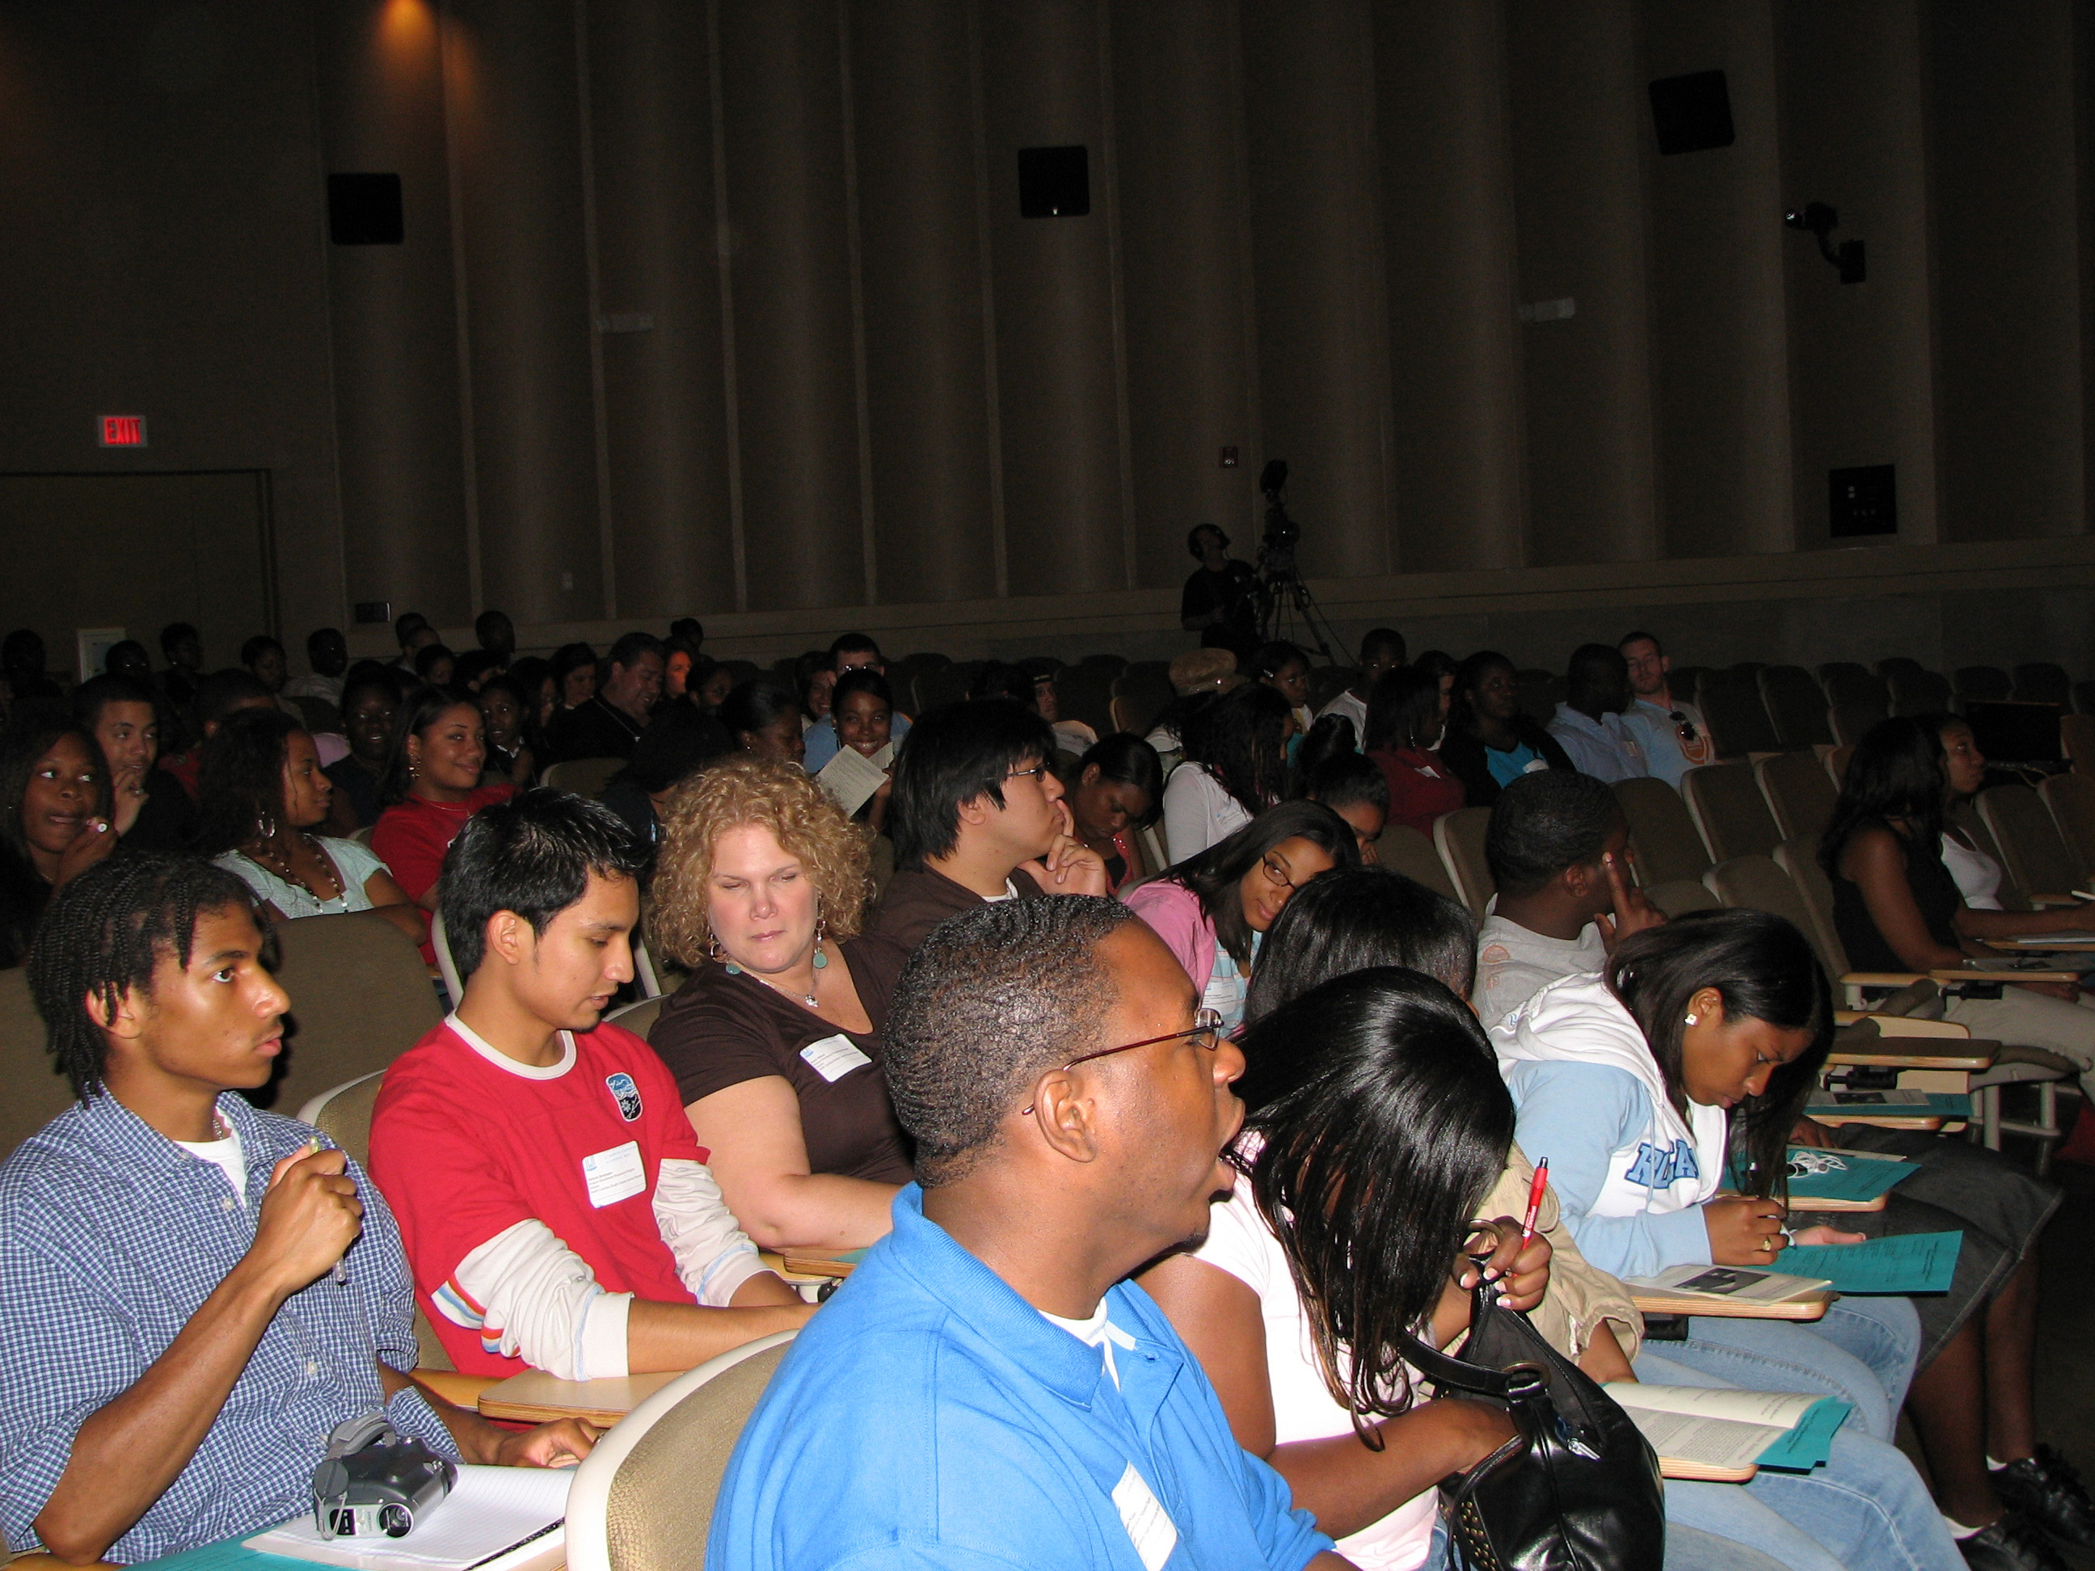 | 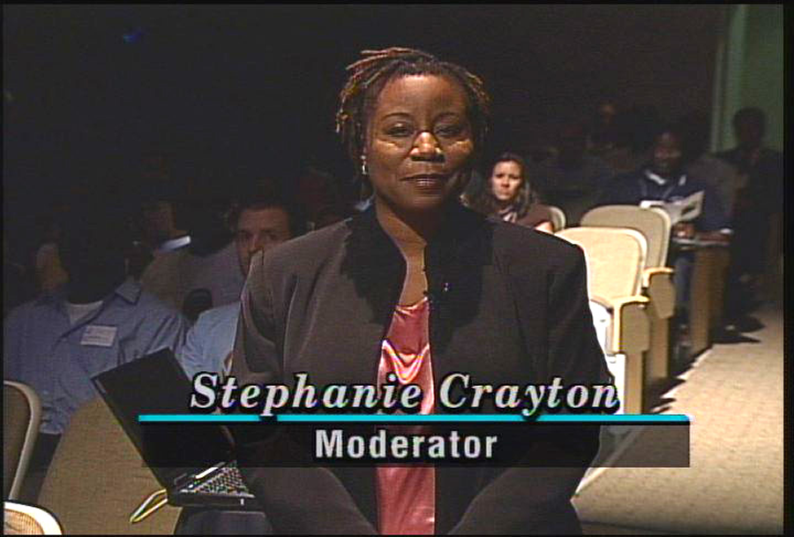 | 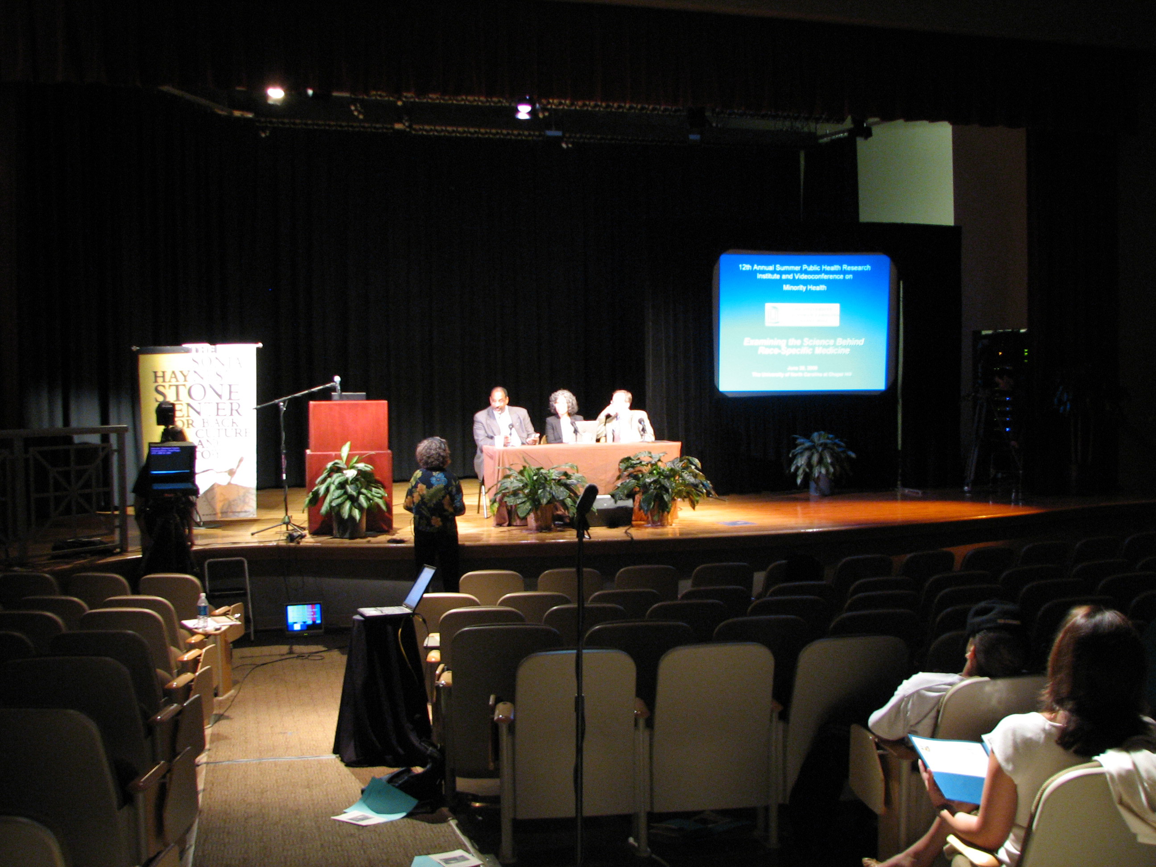

Featured speakers
Claudia R. Baquet, M.D.,M.P.H.
Spero M. Manson, Ph.D.
Abel Valenzuela, Jr., Ph.D.
Frank Y. Wong, Ph.D.
Presented by the
Minority Health Project (UNC Program on Ethnicity, Culture, and Health Outcomes), UNC Diversity and Multicultural Affairs,
and NC A&T State University Institute for Public Health
Sponsors to date
NC A&T State University Institute for Public Health,
UNC School of Public Health Dean’s Office
UNC Diversity and Multicultural Affairs
www.minority.unc.edu


Satellite and Internet broadcast, June 3, 2008
“Men's Health Disparities”

 |  | 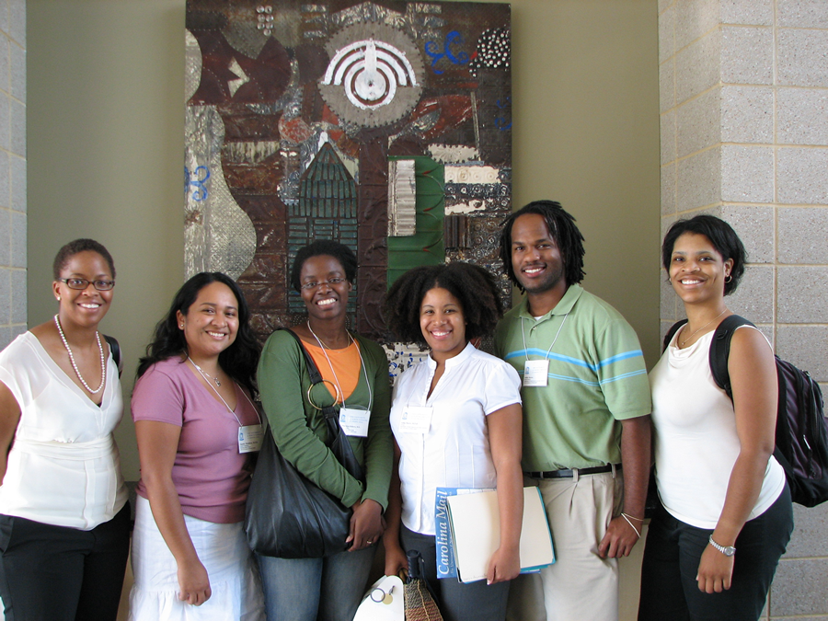

Panel:
Claudia R. Baquet, M.D.,M.P.H., Professor, Departments of Medicine, Epidemiology and Preventive Medicine, University of Maryland School of Medicine; Associate Dean for Policy and Planning; Director, Center for Health
Spero M. Manson, Ph.D., Professor, Department of Psychiatry, University of Colorado at Denver and Health Sciences Center, and Director, National Center for American Indian and Alaska Native Mental Health Research
Abel Valenzuela, Jr., Ph.D., Professor, Department of Urban Planning and the César E. Chávez Department for Chicana/o Studies, University of California, Los Angeles, and Director, Center for the Study of Urban Poverty
Frank Y. Wong, Ph.D., Associate Professor, Department of International Health, School of Nursing and Health Studies, Georgetown University
Moderator: Stephanie L. Crayton, Media Relations Manager, UNC Health Care
www.minority.unc.edu
Archived from February 29: “The Science and Epidemiology of
Racism and Health in the United States: an Ecosocial Perspective”

