__________________________________________
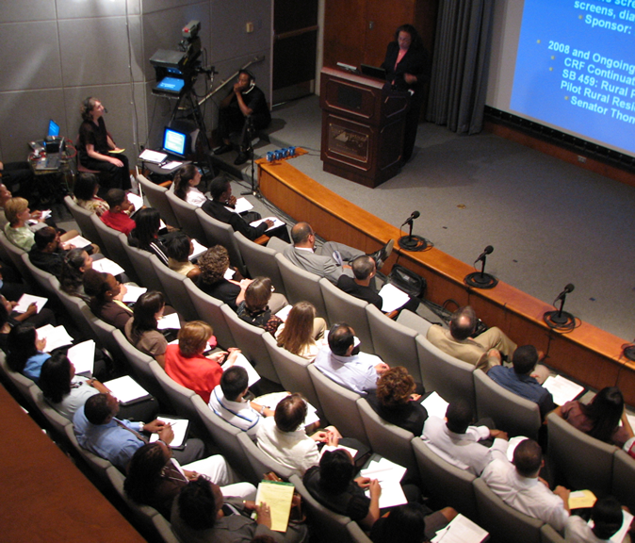
The University of North Carolina
- UNC Gillings School of
Global Public Health
- Minority Health Project
- Diversity and Multicultural Affairs
Breaking the Cycle: Investigating the Intersection of Educational Inequities and Health Disparities
The 15th Annual Summer Public Health Research Videoconference on Minority Health
Reginald Weaver, Dina Castro,
Nicholas Freudenberg, Lillian Sparks
Moderator: Howard Lee

June 9, 2009, 1:30-4:00pm EDT Tate-Turner-Kuralt Auditorium Live Interactive Broadcast
www.minority.unc.edu
__________________________________________

__________________________________________
The University of North Carolina
- UNC Gillings School of
Global Public Health
- Minority Health Project
- Diversity and Multicultural Affairs
Breaking the Cycle: Investigating the Intersection of Educational Inequities and Health Disparities
The 15th Annual Summer Public Health Research Videoconference on Minority Health
Reginald Weaver, Dina Castro,
Nicholas Freudenberg, Lillian Sparks
Moderator: Howard Lee

June 9, 2009, 1:30-4:00pm EDT Tate-Turner-Kuralt Auditorium Live Interactive Broadcast
www.minority.unc.edu
______________________________
_________________________________________
The University of North Carolina
- UNC Gillings School of
Global Public Health
- Minority Health Project
- Diversity and Multicultural Affairs
Breaking the Cycle: Investigating the Intersection of Educational Inequities and Health Disparities
The 15th Annual Summer Public Health Research Videoconference on Minority Health
Reginald Weaver, Dina Castro,
Nicholas Freudenberg, Lillian Sparks
Moderator: Howard Lee

June 9, 2009, 1:30-4:00pm EDT Tate-Turner-Kuralt Auditorium Live Interactive Broadcast
www.minority.unc.edu
__________________________________________

__________________________________________
The University of North Carolina
- UNC Gillings School of
Global Public Health
- Minority Health Project
- Diversity and Multicultural Affairs
Breaking the Cycle: Investigating the Intersection of Educational Inequities and Health Disparities
The 15th Annual Summer Public Health Research Videoconference on Minority Health
Reginald Weaver, Dina Castro,
Nicholas Freudenberg, Lillian Sparks
Moderator: Howard Lee

June 9, 2009, 1:30-4:00pm EDT Tate-Turner-Kuralt Auditorium Live Interactive Broadcast
www.minority.unc.edu
_______________________________________
__________________________________________
Free archived webcasts currently available:
Our World, Our Community: Building Bridges for Health Equality (Barbara Wallace, 2009)
Men’s Health Disparities (Claudia Baquet, Spero Manson, Abel Valenzuela, Frank Wong, 2008)
The Science and Epidemiology of Racism and Health in the United States: an Ecosocial Perspective – from the 29th Annual Minority Health Conference (Nancy Krieger, 2008)

Does racism make us sick? (Karina Walters, Gilbert Gee, Luisa Borrell , David Williams, 2007)

AIDS at 25 (David Malebranche, 2007)

Examining the scientific basis for race-specific medicine (Joseph Graves, Pilar Ossorio, Morris Foster, 2006)

Tobacco Use Prevention Initiatives at HBCUs (2006)

Collaborative Research with Communities (Meredith Minkler)

Confronting Institutional Racism (Camara Jones)

Roots of American Indian/Alaska Native: Indigenous Health Disparities (Michael Bird)

Social Determinants of Health (Sherman James)

It’s all at www.minority.unc.edu
Vic Schoenbach, Minority Health Project webmaster
___________________________________________

___________________________________________
Free archived webcasts currently available:
Our World, Our Community: Building Bridges for Health Equality (Barbara Wallace, 2009)
Men’s Health Disparities (Claudia Baquet, Spero Manson, Abel Valenzuela, Frank Wong, 2008)
The Science and Epidemiology of Racism and Health in the United States: an Ecosocial Perspective – from the 29th Annual Minority Health Conference (Nancy Krieger, 2008)

Does racism make us sick? (Karina Walters, Gilbert Gee, Luisa Borrell , David Williams, 2007)

AIDS at 25 (David Malebranche, 2007)

Examining the scientific basis for race-specific medicine (Joseph Graves, Pilar Ossorio, Morris Foster, 2006)

Tobacco Use Prevention Initiatives at HBCUs (2006)

Collaborative Research with Communities (Meredith Minkler)

Confronting Institutional Racism (Camara Jones)

Roots of American Indian/Alaska Native: Indigenous Health Disparities (Michael Bird)

Social Determinants of Health (Sherman James)

It’s all at www.minority.unc.edu
Vic Schoenbach, Minority Health Project webmaster
___________________________________________
__________________________________________
Free archived webcasts currently available:
Our World, Our Community: Building Bridges for Health Equality (Barbara Wallace, 2009)
Men’s Health Disparities (Claudia Baquet, Spero Manson, Abel Valenzuela, Frank Wong, 2008)
The Science and Epidemiology of Racism and Health in the United States: an Ecosocial Perspective – from the 29th Annual Minority Health Conference (Nancy Krieger, 2008)

Does racism make us sick? (Karina Walters, Gilbert Gee, Luisa Borrell , David Williams, 2007)

AIDS at 25 (David Malebranche, 2007)

Examining the scientific basis for race-specific medicine (Joseph Graves, Pilar Ossorio, Morris Foster, 2006)

Tobacco Use Prevention Initiatives at HBCUs (2006)

Collaborative Research with Communities (Meredith Minkler)

Confronting Institutional Racism (Camara Jones)

Roots of American Indian/Alaska Native: Indigenous Health Disparities (Michael Bird)

Social Determinants of Health (Sherman James)

It’s all at www.minority.unc.edu
Vic Schoenbach, Minority Health Project webmaster ___________________________________________

___________________________________________
Free archived webcasts currently available:
Our World, Our Community: Building Bridges for Health Equality (Barbara Wallace, 2009)
Men’s Health Disparities (Claudia Baquet, Spero Manson, Abel Valenzuela, Frank Wong, 2008)
The Science and Epidemiology of Racism and Health in the United States: an Ecosocial Perspective – from the 29th Annual Minority Health Conference (Nancy Krieger, 2008)

Does racism make us sick? (Karina Walters, Gilbert Gee, Luisa Borrell , David Williams, 2007)

AIDS at 25 (David Malebranche, 2007)

Examining the scientific basis for race-specific medicine (Joseph Graves, Pilar Ossorio, Morris Foster, 2006)

Tobacco Use Prevention Initiatives at HBCUs (2006)

Collaborative Research with Communities (Meredith Minkler)

Confronting Institutional Racism (Camara Jones)

Roots of American Indian/Alaska Native: Indigenous Health Disparities (Michael Bird)

Social Determinants of Health (Sherman James)

It’s all at www.minority.unc.edu
Vic Schoenbach, Minority Health Project webmaster ___________________________________________

