15th Annual Summer Public Health Research Videoconference on Minority Health

“Breaking the Cycle: Investigating the Intersection of Educational Inequities and Health Disparities”

June 9, 2009, via C-band satellite and Internet webcast from the
Tate-Turner-Kuralt auditorium, UNC School of Social Work
Program begins at 1:30pm EDT (10:30am PDT, 11:30pm MDT, 12:30pm CDT)
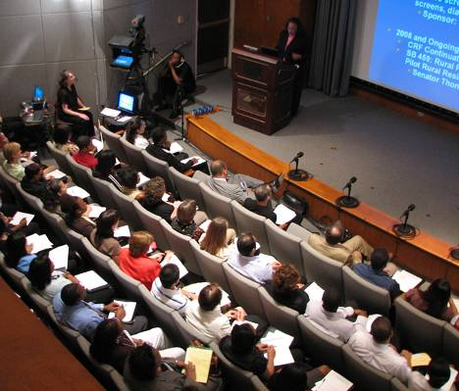
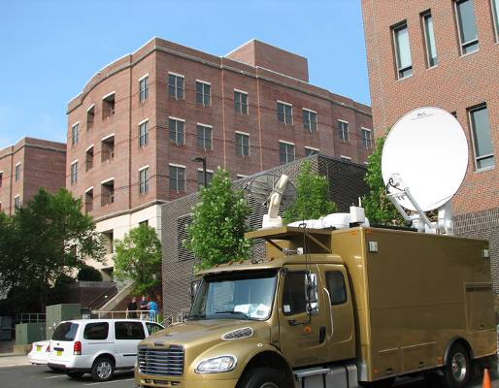
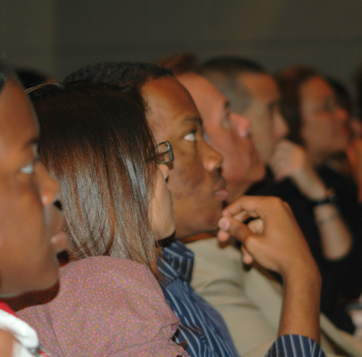

Presenters
Reginald Weaver, DIP(hon), DHL(hon), DPS(hon)
Vice President, Education International
Dina C. Castro, MPH, PhD
Scientist, UNC FPG Child Development Center
Nicholas Freudenberg, DrPH
Distinguished Professor, Hunter College School of Health Sciences/CUNY
Lillian A. Sparks, JD
Executive Director, National Indian Education Association
Howard N. Lee, MSW, Moderator
Executive Director, North Carolina Education Cabinet
Presented by the
Minority Health Project (UNC Program on Ethnicity, Culture, and Health Outcomes)
UNC Gillings School of Global Public Health
UNC Diversity and Multicultural Affairs
www.minority.unc.edu

