16th Annual Summer Public Health Research Institute and
Videoconference on Minority Health

What Will Health Care Reform Mean for Minority Health Disparities?
www.minority.unc.edu/institute/2010/

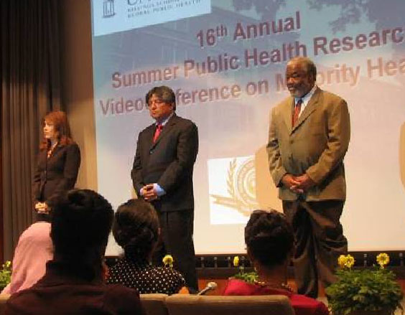

Presenters:
Mayra Alvarez, MHA, Legislative Assistant to U.S. Senator Richard Durbin and now with the HHS Office of Health Care Reform

Ralph Forquera, MPH, Director, Seattle Indian Health Board and Clinical Assistant Professor, School of Public Health, Department of Health Sciences, University of Washington

Tony Whitehead, PhD, M.S.Hyg., Professor of Medical Anthropology and founding Director, Cultural Systems Analysis Group (CuSAG), Department of Anthropology, University of Maryland

Moderator: Howard Lee, Executive Director of North Carolina Education Cabinet

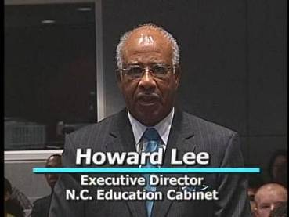
(biographies are at www.minority.unc.edu/institute/2010/ )
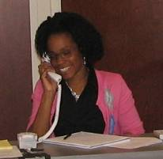
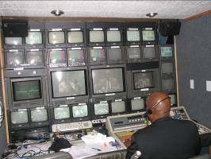

Conference Location and Date: Internet broadcast from the UNC School of Social Work Tate-Turner-Kuralt Building Auditorium, Tuesday, June 8, 2010

Presented by: UNC Diversity and Multicultural Affairs
UNC Gillings School of Global Public Health Minority Health Project
with a major cosponsorship from Norfolk State University Ethelyn R. Strong School of Social Work

Additional cosponsors: 14 financial, 2 in-kind, plus 4 additional partners (including two programs for underrepresented minority students interested in the health professions), 12 additional endorsements (see list at www.minority.unc.edu/institute/2010/cosponsors.cfm)

News coverage:
ASPH Friday Letter - http://fridayletter.asph.org/press.cfm?fl_index=1619
Local papers
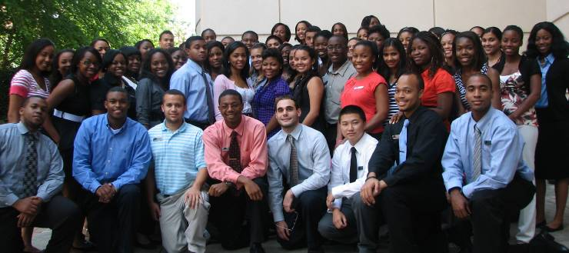

Websites:
More than 35 non-UNC websites listed the 16th Annual Videoconference as of 9/12/2010. The program was carried live on blackradionetwork.com. Selected institutions/organizations that linked to the videoconference are listed below:

National Network to Eliminate Disparities (NNED) in Behavioral Health
Virginia Commonwealth University – Tompkin-McCaw Library for the Health Sciences
Bryn Mawr College Graduate School of Social Work & Social Research
U.S. Department of Health and Human Services – Office of Minority Health
California State University Long Beach – Research Infrastructure in Minority Institutions (RIMI) Project
Duke University Global Health Institute
Minnesota Institute of Public Health
Global Pulse Journal (AMA Student Association’s International Health Journal)
Center for Health and Health Care in Schools
New York University Social Work Student Affairs
Indians Into Medicine (INMED) [in Facebook]
Dana-Farber/Harvard Cancer Center
New York State Department of Health
Kaiser Family Foundation KaiserEdu.org
University of Kentucky School of Public Health
Mississippi County Health Department
New Jersey Learning Management Network, Rutgers University
Wayne State University Center for Social Work Practice and Policy Research
Community Health Center Association of Connecticut
Families USA
Urban Health Today Blog
Health Disparities Resource List at Wake Community
The Mayor’s Health Line Blog, Boston Public Health Commission

Estimated live viewing audience: 1,000

Archived webcast visitors:
Over 100 visitors submitted the registration form to view the archived webcast (generally about the same number access the webcast via a link that bypasses the registration form). Registered visitors:
- came from 20 US states
- most were affiliated with educational organizations (47%), health departments or other government (24%), health care providers (14%), community/consumer groups (11%)
- the majority asked to receive email announcements.
During the past 12 months there were also over 70 visitors to the webcast of last year’s Videoconference, 45 for the previous year’s, 105 for the 2007 Videoconference (680 registered visitors in all during the past 12 months).
Registration statistics summary

Group viewing sites
76 group viewing sites registered, from 25 states (North Carolina had 17 sites; Florida, Texas, and Virginia had 6 sites each). Primary locations for sites (Table 1) were educational/ research organizations (27), local health departments (24), and other government and municipal agencies (8).

Table 1. Group viewing sites, by category
 | N | 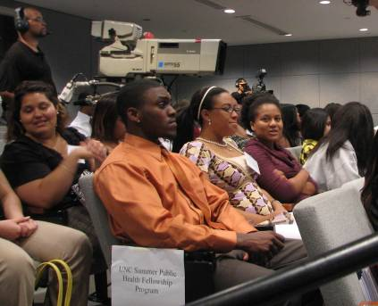  %
Educational/ Research organizations | 27 | 36
Health Department | 24 | 31
Other government, Municipal Agency | 8 | 11
Community Organizations | 5 | 7
Hospital, Medical Practice if Nursing Home | 4 | 5
Other | 8 | 10

Registered participants

There were over 800 registrants (onsite plus webcast), from 45 U.S. states (especially North Carolina [210], California [70], Texas [65], and VA and MD (each about 40) and 6 countries (Canada, Nigeria, South Africa, Thailand, the United Kingdom, and Vietnam). Registrants were affiliated with educational organizations, health departments, health care providers, government organizations, and community organizations (Table 2).

Table 2. Videoconference registrant affiliations
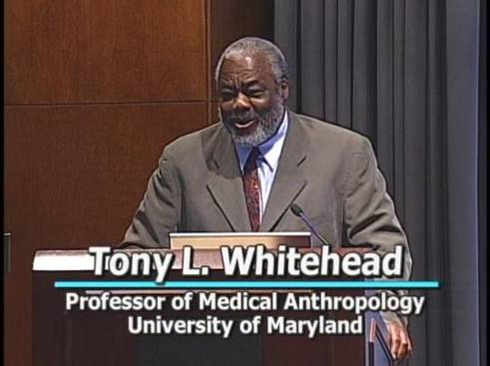 | N | %
Educational | 260 | 33
Health department | 135 | 17
Other government | 162 | 21
Community/Consumer | 107 | 14
Hospital, other medical | 87 | 11
Other | 31 | 4
Note: includes persons specifying an affiliation even if they were registering a group viewing site.

Evaluation response summary

Site facilitators

Online evaluation forms were received from 41 site facilitators. The majority of sites successfully received the broadcast (Table 3) and reported a total of 343 participants (about 8.4 participants per site). DVD copies of the broadcast were mailed to several of the sites that were unable to view the live broadcast. Projecting the reported participants to all 76 sites suggests that there may have been about 525 participants at group viewing sites.

Table 3. Group viewing site facilitator reports
 | N | 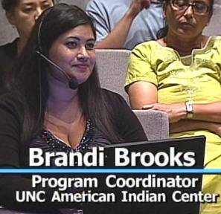
Received (several had audio difficulties or Internet delays) | 39
Could not view due to IT problem | 2
No response | 35
Total | 76

The 41 site facilitators who provided ratings gave very favorable ones: 85% said participants seemed engaged, 87% said participants found the material interesting and important, 86% said the time for presentations was about right, 59% said participants felt able to ask questions, 90% said the website was well-organized, convenient, informative , and 89% said that compared to others this broadcast was well organized and run. 82% said they would recommend this broadcast to other organizations.

Participant evaluations

Online evaluations were submitted by 355 participants (175 who viewed on a PC, 122 who viewed at a group viewing site, 53 in the studio audience; 5 unstated). A small number of respondents indicated that they were unable to view the broadcast, because of technical problems.

The overwhelming majority of participants who viewed the broadcast gave it favorable ratings (Table 4). Large percentages said that the "Videoconference increased my understanding of this subject and its relation to public health" (94% "strongly agree" or "agree"), "topics covered were important and relevant to the issue of health disparities" (97%), the Videoconference was "very valuable for me" (85%), and that they would "highly recommend the Videoconference" (85%).

Table 4. Participant ratings
The Videoconference increased my understanding of this subject and its relation to public health.
Strongly agree | 123 | 36%
Agree | 199 | 58%
Neutral | 18 | 5%
Disagree (or Strongly) | 5 | 1%
The topics covered today were important and relevant to the issue of health disparities.
Strongly agree | 173 | 50%
Agree | 163 | 47%
Neutral | 8 | 2%
Disagree (or Strongly) | 3 | 1%
Overall, the Videoconference was very valuable for me.
Strongly agree | 124 |  |  | 36%
Agree | 172 |  |  | 49%
Neutral | 45 |  |  | 13%
Disagree (or Strongly) | 6 |  |  | 2%
I will highly recommend the Videoconference.
Strongly agree | 139 |  | 40%
Agree | 152 |  | 45%
Neutral | 45 |  | 13%
Disagree (or Strongly) | 6 |  | 2%

Sample participant comments (some may have declined to have comment appear publicly)

“Enjoyed the discussion re: Urban Indians.”

“This was a very informative conference. Thank you for the experience.”

“Good info for planning and programming to address critical needs”

“There is so much to discover and understand about the Affordable Health Care Act, it was very valuable to have the overview of the bill and focus on how it may influence a major health care issue. “

“It was very interesting for me. The speakers kept my attention the whole conference. I really like Mr. Ralph Forquera, MPH, he talked about a subject I don't hear a lot about, The Indian Health System.”

“All of the presenters were engaging, informative and clearly have command of their subject area(s)and are strong advocates for individuals experiencing disparities in the areas of health, education and access to much needed services and support systems.”

“Each speaker presented their material in a well organized manner with confidence in the way they communicated the information to the listening audience.”

“Nice job. Thanks for offering this at no cost and so conveniently via the webcast. Interesting content. Good presentations.”

“I appreciate the collaboration between community, academic and political settings to address the all important issue of health and healthcare disparities. Until everyone has equal access to the many opportunities afforded in the United States, we will never see the full potential of our nation. - Alison Weston”

“Ms. Alvarez and Mr. Forquera had very good specific information related to the impact of the health care reform. Mr. Whitehead was good but not as informative to the the topic. The Q&amp;A provide more"meat"to some of the questions I was seeking answers too. Still like to know more of the impact on public health and what will be public health's role.”

“The conference overall was quite informative and helpful. The speakers were excellent and their expertise apparent. This will be good information that I can share with others to clarify this portion of the Health Reform Bills. Thank you for providing this venue to all of us.”

“All of the speakers did a phenomenal job. I especially enjoyed hearing about how health disparities affect urban American Indian populations and more information about health reform bill that was recently passed.”

To view all 122 comments (i.e., all those except 36 not authorized for public dissemination), visit:
www.minority.unc.edu/institute/2010/eval/comments.cfm

To view 36 comments not authorized for public dissemination, please communicate with Victor Schoenbach, vjs@unc.edu.

Ché Smith and Victor J. Schoenbach, www.unc.edu/~vschoenb/, 9/12,19/2010

