16th Annual Summer Public Health Research Videoconference on Minority Health

“What Will Health Care Reform Mean for
Minority Health Disparities”

June 8, 2010, via Internet webcast from the
Tate-Turner-Kuralt auditorium, UNC School of Social Work
Program begins at 1:30pm EDT (10:30am PDT, 11:30pm MDT, 12:30pm CDT)
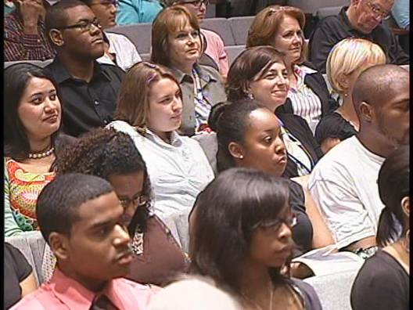
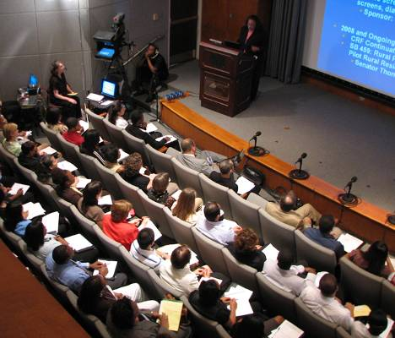


Presenters
Mayra Alvarez, MHA
Legislative Assistant for Health for U.S. Senator Richard Durbin
Ralph Forquera, MPH
Director, Seattle Indian Health Board
Tony Whitehead, MSHyg, PhD
Professor of Medical Anthropology, University of Maryland
Howard N. Lee, MSW, Moderator
Executive Director, North Carolina Education Cabinet
Presented by
UNC Diversity and Multicultural Affairs
Minority Health Project (UNC Program on Ethnicity, Culture, and Health Outcomes)
UNC Gillings School of Global Public Health
UNC Institute of African American Research
Norfolk State University Ethelyn R. Strong School of Social Work
www.minority.unc.edu

