Report on the
17th Annual Summer Public Health Research Institute and
Videoconference on Minority Health

Health Equity: Progress and Pitfalls
www.minority.unc.edu/institute/2011/

“The videoconference provided very thorough and insightful information I can use in working with my students on issues that impact the health of minorities.” (webcast viewer, Albany, NY)

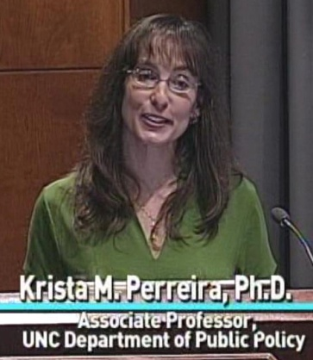
“A compelling set of presentations on key issues of the broader determinants of health.” (webcast viewer, British Columbia, CA)

“All of the presenters were phenomenal, and the moderator was dynamic.” (studio audience participant)

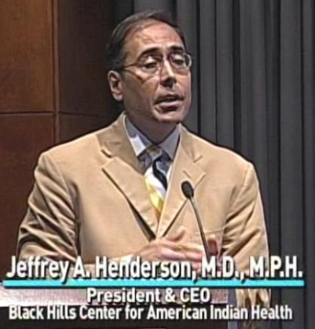
“Fabulous work, wonderful contribution. Thank you very much for making this information so accessible.” (archived webcast viewer, Michigan)

“This was by far the most clear webinar I have attended by any agency/group. Thank you!” (webcast viewer, Washington state)

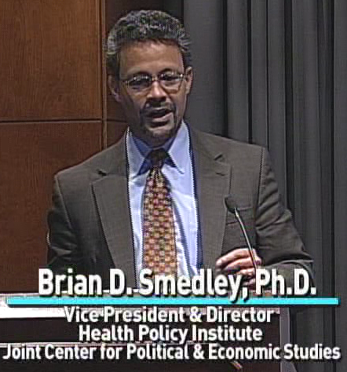

“The conference inspired me and was deeply touching.” (webcast viewer, Madison, WI)

Presenters: Krista M. Perreira, Jeffrey A. Henderson, Brian D. Smedley, and guest panelist M. Cookie Newsom
(titles and biographies are at www.minority.unc.edu/institute/2011/ )

Moderator: Barbara Pullen-Smith, MPH – Director, North Carolina Office of Minority Health and Health Disparities and Past President, National Association of State Offices of Minority Health (NASOMH)

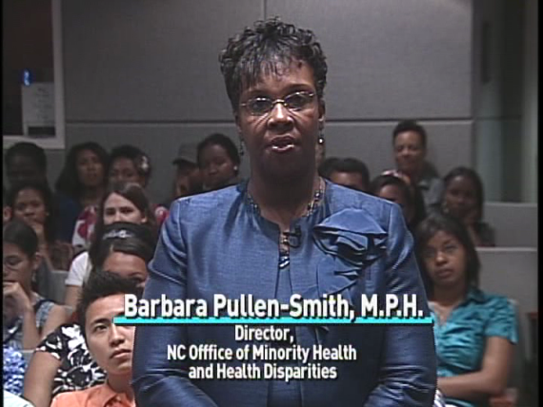
Conference Location and Date: Internet broadcast from the UNC School of Social Work Tate-Turner-Kuralt Building Auditorium, Tuesday, June 7, 2011

Presented by: UNC Gillings School of Global Public Health, Minority Health Project
UNC Diversity and Multicultural Affairs
UNC American Indian Center
Norfolk State University Ethelyn R. Strong School of Social Work

Patron sponsors: UNC Gillings School of Global Public Health
UNC Diversity and Multicultural Affairs

Cosponsors: 12 financial, 2 in-kind, plus 17 endorsements (see list at www.minority.unc.edu/institute/2011/cosponsors.cfm)

Planning Committee:
Danny Bell, Ronny Bell, Brandi Brooks (co-coordinator), Kristin Black (co-coordinator), Dorothy Browne, DeVetta Holman-Nash, Bill Jenkins (program chair), Alexandra Lightfoot, O.J. McGhee (producer/director), Cookie Newsom (co-chair), Josmell Perez, Victor J. Schoenbach (co-chair), Sharon Holmes Thomas

Additional credits and acknowledgements: www.minority.unc.edu/institute/2011/credits.cfm

Impact indicators:
23 non-UNC websites listed the 17th Annual Videoconference as of 7/4/2011.
Estimated viewing audience:
- Over 2,000 unique IP addresses were logged for the Videoconference website
- Over 500 unique IP addresses visited the website on the day of the broadcast
- About 350 unique IP addresses visited the webcast page on the day of the broadcast (the vendor reported 325 unique IP addresses received the webcast)
- Projected attendance at 36 group viewing sites was 240 viewers
- On-site audience at Tate-Turner-Kuralt included 50 NC-HCAP, 33 SPHF, 47 other.

Estimated live viewing audience: 660

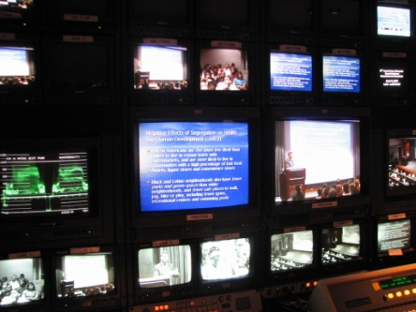
Archived webcast visitors: 180 additional IP addresses visited the archived webcast page as of 7/9/2011. About 140 submitted a registration form; over half of these registrants were at an educational or research institution, and many mentioned a course or teacher as the source of their information. Registration forms came from 20 states. There were also about 25 visitors who registered to view a previous Videoconference.
On July 7th, the University of Illinois, Chicago School of Public Health used the archived version of the broadcast for a program with 45 participants at UIC – 40 students from over 20 Chicago high schools and five undergraduates (from UIC, Pittsburgh, Bowdoin, Colorado College, Colgate. Additionally, 15 high school students (American Cancer Society interns) joined in remotely from five rural sites in Illinois and elsewhere. The program included a presentation by APHA President Dr. Linda Rae Murray (at UIC), viewing of the archived presentations by Krista Perreira and Brian Smedley, and discussion and audience questions, with a panel at UIC.
UNC publicity:
www.sph.unc.edu/schoolwide_news/minority_health_videoconference_takes_stock_of_health_disparities_progress_19194_8289.html
Registration statistics summary

Group viewing sites
36 group viewing sites registered, from 16 states (North Carolina had 10 sites; Virginia had 4 sites; Texas had 3 sites) and one site abroad in Ile-de-France. Primary locations for sites (Table 1) were educational/ research organizations (44%), local health departments (9%), and other government and municipal agencies (6%).

Table 1. Group viewing sites, by category
 | N | %
Educational/ Research organizations | 16 | 44
Health Department | 9 | 25
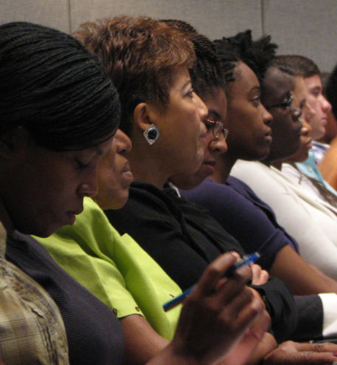  Other government, Municipal Agency | 6 | 17
Community Organizations | 3 | 8
Hospital, Medical Practice if Nursing Home | 2 | 6
Other

Registered participants

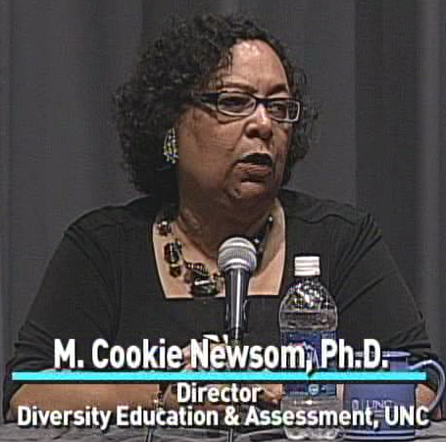
Webcast registrants (580) came from 49 U.S. states (especially North Carolina [146], NY [38], California [36], Virginia [35], Georgia [29], Texas [28], and MD [28]) and 3 countries (including Canada, Sweden, and France). Registrations came primarily from people in education/research organizations (35%), government/municipal agencies (22%), community organizations (13%), health departments (16%), health care organizations (10%).
Evaluation response summary

Site facilitators

Information about attendance was received from 25 of the 36 group viewing sites. Two sites reported being unable to receive the broadcast, and the remaining sites reported 190 participants in all. Projecting this attendance to the remaining 11 sites leads to a projection of 245 participants at group viewing sites.
The 12 site facilitators who provided ratings on the survey gave very favorable ones: 100% said participants seemed engaged, 100% said participants found the material interesting and important, 82% said the time for presentations was about right, 82% said the time allotted for questions and comments was about right, 55% said participants felt able to ask questions, 82% said the website was well-organized, convenient, informative, and 100% said that compared to others this broadcast was well organized and run. 91% said they would recommend this broadcast to other organizations.

Participants

Online evaluations were submitted by 229 participants (including 159 viewing on a PC, 30 at a group viewing site, 30 in the studio audience). Very few indicated any technical difficulties in viewing.

The overwhelming majority of participants rated it highly (Table 4). Large percentages said they either “strongly agree” or “agree” that the:
- "Videoconference increased my understanding of this subject and its relation to public health" (92%);
- "Topics covered were important and relevant to the issue of health disparities" (99%);
- “Videoconference was very valuable for me" (93%); and
- They would "highly recommend the Videoconference" (93%).

Table 2. Participant ratings (tabulation of 229 able to view)
The Videoconference increased my understanding of this subject and its relation to public health.
Strongly agree | 104 | 48%
Agree | 99 | 45%
Neutral | 15 | 7%
Disagree (or Strongly) | 1 | -
The topics covered today were important and relevant to the issue of health disparities.
Strongly agree | 151 | 69%
Agree | 67 | 30%
Neutral | 1 | 0.5%
Disagree (or Strongly) | 1 | 0.5%
Overall, the Videoconference was very valuable for me.
Strongly agree | 113 |  |  | 51%
Agree | 93 |  |  | 42%
Neutral | 13 |  |  | 6%
Disagree (or Strongly) | 1 |  |  | 0.5%
I will highly recommend the Videoconference.
Strongly agree | 125 |  | 57%
Agree | 79 |  | 36%
Neutral | 13 |  | 6%
Disagree (or Strongly) | 2 |  | 1%
Sample participant comments
“Thank you for selecting three speakers who were excellent and provided three different and thought provoking perspectives on health disparities. This information is so valuable and I appreciate the provision of the slides and handouts for the presentations. - Sylvia Merino, MBA, MPH, Charles Drew University of Medicine and Science, Clinical Simulations Center” (webcast) Los Angeles, CA

“The speakers were very knowledgeable and dynamic, especially Dr. Smedley and Perreira. The information that they provided was invaluable. Patricia A. DeWitt, New Haven, CT” (webcast) New Haven, CT

“I thought the diversity of the panel was excellent. Very knowledgeable and informative as it relates to thier area of expertise. Really wanted more informatino about what is currently being done (evidence based programming, interventions, and policy) as it relates to health disparities. A report card so to speak as we address health disparities in HP 2020” (via webcast on a computer monitor) Frankfort, Kentucky
“This program was very good and I enjoyed the information, the presentations and the panel. I think it is important that we continue to have conversations about health dispartiies. Kathy Donner, Phoenix, Arizona” (webcast ) Phoenix, Arizona

“The conference inspired me and was deeply touching. However, individually, I feel insignificant because I have very little resource or power to effect change in the right direction. I'd appreciate suggestions about meaningful ways I can contribute to solutions to the challenges highlighted in the presentations.” (via webcast on a computer monitor) Madison, Wisconsin

“Thank you for making speakers' handouts and recorded webcasts available, year-in and year-out... / Solutions to minority health disparities are slow-going, so this event is a good way for me to get a "quick" and "no-cost" recharge to my public health advocacy batteries every June, without having to go out of town!” (webcast) Rock Hill, SC

“I believe this conference was an excellent one, it was the first of its kind for me and I was really impressed with the tech staff using all the various forms of media to communicate with audiences. I, however, was more pleased with the depth and knowledge of the presenters and their focus on continuing research in the area of Minority Health Disparities. They did well, only a little more time for questions next year would be great since we finished well before the allotted time.” (via webcast on a computer monitor) Washington, DC

“All speakers were excellent. I was glad to hear more about the American Indian/Alaskan Native population. That's been lacking a bit in other minority health presentations I have attended. Really enjoyed Dr. Smedley's presentation and thoughts on politics/public policy.” (via webcast on a computer monitor) Chapel Hill, NC

“The videoconference provided very thorough and insightful information I can use in working with my students on issues that impact the health of minorities. I was very grateful for the presentation on American Indians/American Eskimos. I will be addressing this community and issues that impact them in a summer course and the information was most helpful” (via webcast on a computer monitor) Albany, New York

“This webconference is a very useful way to connect with other professionals in the field of health disparities.” (via webcast on a computer monitor) Laurel, MD

“This videoconference has proven valuable my colleagues and I are in the processes of developing startegic plans for our regions. As a health equity director, it has only reinforced the messaging we are trying to get across to others in the community, and in sharing this information with them, it is my hope that we can begin the hard work required to strengthen our communities. Sandii Leland Handrick / Regional Director, Health Equity / American Heart Association Midwest Affiliate / St. Louis, MO” (via webcast on a computer monitor) St. Louis, MO

“This was by far the most clear webinar I have attended by any agency/group. Thank you!” (webcast) Washington

“A compelling set of presentations on key issues of the broader determinants of health.” (webcast) Vancouver, BC, Canada

“The videoconference motivated me to put more effort into conducting research and activities related one of my areas of interest which is the health literacy of African American males. Margaret D. Knight, Ed. D. Department Chair, Early Childhood/Elementary and Special Education at Norfolk State University in Norfolk, VA” (via webcast on a computer monitor) Norfolk, VA

“This is a valuable presentation to health providers, which can be accessed remotely from our offices,without too much disruption to our clinical schedules. The ideas on population health and health paradox in our immigrant children are crucial to understand if we want to affect change in this group of Americans. Marisa Kathard Flores MD, pediatrician in Chapel Hill.” (via webcast on a computer monitor) Chapel Hill, NC

“All speakers were very good and the information highlighted by each was excellent. Dr. Perreira's discussion on the impact of migration (all phases) was insightful. Dr. Smedley's presentation highlighted the conference for me. His insights into how segregation impacts health disparities was revealing. All speakers demonstrated the understanding of the issue and the information increased by knowledge base.” (webcast) Albany, New York

“Thank you for an excellent set of presenters and presentations. The focus on the impact of education and the economy on health will help to shape my thinking for future professional presentations and writing. I have shared the link to the archived webcast with some local community leaders who have an interest in addressing health concerns of African Americans in the Akron, Ohio area. / Martha E. Banks, Ph.D., Research Neuropsychologist, ABackans DCP, Inc., Akron, OH” (via webcast on a computer monitor) Akron, OH

“I think having a strong focus on Native Americans is important to understanding their unique place in minority/marginalized health. While Black Americans have poor health status in the US compared to White Americans, because of the larger population, there is more data and a greater focus on this minority population. Native Americans often are too few to stratify in survey samples and this makes it important to ensure their seat at the table when conversations about improving minority health are occuring. I would like to applaud the conference for focusing on this group as a central part of the conference.” (webcast) Sacramento, CA

“All of the presenters were phenomenal, and the moderator was dynamic. I personally found the presentation by Dr. Brian D. Smedley the most insightful and useful to the daily application of program evaluation and implementation for low SES populations and other priority populations.” (studio audience) Chapel Hill, NC

“The speakers were really good and the conference was an eye opener for me. The topics discuss were very enlightening and I believe people need to begin to raise their voices vis-à-vis issues concerning the minority groups in this country. The gap is too wide; it’s high time to begin to bridge it.” (webcast) Norfolk, VA

“Fabulous work, wonderful contribution. Thank you very much for making this information so accessible.” (archived webcast viewer, Michigan)

To view all comments except the 24 not authorized for public dissemination, visit:
http://www.minority.unc.edu/institute/2011/eval/comments.cfm (To view the 24 comments not authorized for public dissemination, please communicate with Victor Schoenbach, vjs@unc.edu.)

