7th Annual Summer Public Health Research Videoconference on Minority Health

“Health Equity: Progress and Pitfalls”

Recorded June 7, 2011 and now online at www.minority.unc.edu
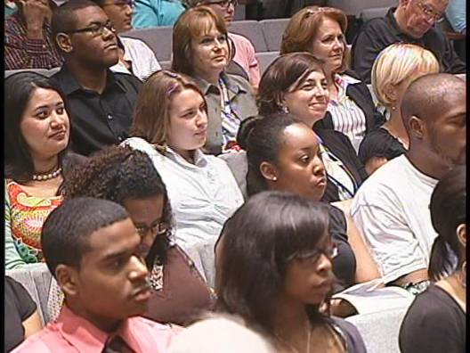



Presenters
Krista M. Perreira, PhD
Associate Professor, Department of Public Policy, UNC at Chapel Hill
Jeffrey A. Henderson, MD, MPH
President and CEO, Black Hills Center for American Indian Health
Brian D. Smedley, PhD
Vice President and Director, Health Policy Institute, Joint Center for Political and Economic Studies
M. Cookie Newsom, PhD
Director of Diversity Education and Assessment, UNC at Chapel Hill
Barbara Pullen-Smith, MPH, Moderator
Director, North Carolina Office of Minority Health and Health Disparities and
Past-President, National Association of State Offices of Minority Health
Presented by
UNC Diversity and Multicultural Affairs, Minority Health Project, UNC Gillings School of Global Public Health, UNC American Indian Center, Norfolk State University Ethelyn R. Strong School of Social Work, a partner in the Commonwealth Public Health Training Center
www.minority.unc.edu

