UNC-Chapel Hill School of Public Health

Minority Student Caucus presents its
28th Annual Minority Health Conference

Friday, February 23rd, 2007 at the
William and Ida Friday Center, Chapel Hill

plus an interactive satellite and Internet broadcast
of the 9th Annual William T. Small, Jr. Keynote Lecture

(broadcast time 2:00 pm-3:30 pm EST
includes live telephone/email question and answer session)

Keynote: “AIDS at 25:
It’s Time to Deliver”
David J. Malebranche, M.D.,M.P.H.
Assistant Professor
Emory University School of Medicine

Information at www.minority.unc.edu

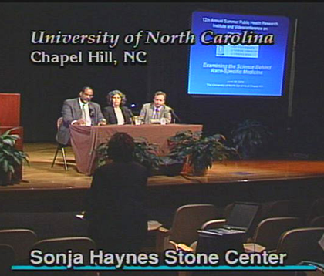
Coming June 25, 2007:

13th Annual Summer Public Health Research Videoconference
on Minority Health (free downlink from UNC-CH)
Presented by the Minority Health Project
in collaboration with Morgan State University
www.minority.unc.edu – Find a UNC-CH minority health-related event or organization at or list yours; view programs and webcasts from previous conferences; receive e-mail announcements (<12/year); MSC Alumni – visit www.minority.unc.edu/sph/mscalumnet/
June 2006 broadcast
1/20/2007

