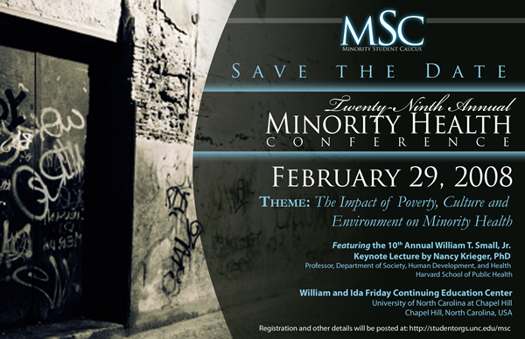
The University of North Carolina
School of Public Health

Minority Student Caucus

presents its
29th Annual Minority Health Conference

Friday, February 29th, 2008 at the
William and Ida Friday Center, Chapel Hill

plus an interactive satellite and Internet broadcast
of the 10th Annual William T. Small, Jr. Keynote Lecture

(broadcast time 2:00 pm-3:30 pm EST
includes live telephone/email question and answer session)

Keynote: “The Science and Epidemiology of Racism and Health in the United States: an Ecosocial Perspective”  Nancy Krieger, Ph.D.  Professor of Society, Human Development, and Health  Harvard School of Public Health  Information at www.minority.unc.edu | 


Coming June 3, 2008:
14th Annual Summer Public Health Research Videoconference
on Minority Health (free downlink from UNC)
Presented by UNC Diversity and Multicultural Affairs, the Minority Health Project, and other partners
June 2006 broadcast
www.minority.unc.edu – For minority health-related events and
organizations, programs and webcasts from previous conferences; receive e-mail announcements (<12/year). MSC Alumni – visit www.minority.unc.edu/sph/mscalumnet/
1/29/2008

