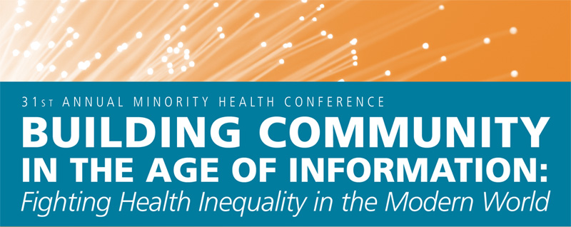
ABSTRACT SUBMISSION FORM
Extended Deadline: Submissions must be received by Friday January 22, 2010
We welcome abstracts from research projects and/or practice-oriented projects from community members or organizations. Please send completed abstract submission form as an email attachment, and any questions to mhcposters@gmail.com.

NAME:
(Last, First Middle)

CREDENTIALS:
(ie: MPH, DrPH, MD, etc.)

IF STUDENT, WHERE?:
(ie: Masters student, Department, UNC Chapel Hill)

IF FACULTY MEMBER, WHERE?:
(ie: Associate Professor, Department, UNC Chapel Hill)

OTHER POSITION/TITLE:
(Please list any other title you wish to appear with your name)

EMAIL ADDRESS:

TELEPHONE:

MAILING ADDRESS:

ABSTRACT TITLE:

ABSTRACT AUTHORS:
(Please list all authors and credentials/titles in the order they should appear in any printed materials)

ABSTRACT TEXT:
(Please limit your text to 250 words or less, and organize by sub-headings: Introduction, Methods, Results, and Conclusion (for traditional research) or as appropriate for your project)

