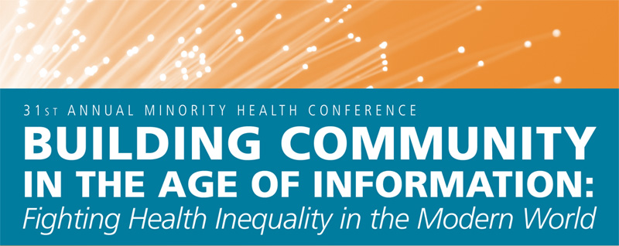

CALL FOR POSTER ABSTRACTS
The Minority Student Caucus at the UNC Gillings School of Global Public Health invites you to submit abstracts for poster presentations during the 31st Annual Minority Health Conference.
We welcome abstracts for research projects and for projects from community members or organizations
Extended Deadline: All poster abstracts must be received by Friday January 22, 2010.
Please fill out the form available at http://www.minority.unc.edu/sph/minconf/2010/ and submit to mhcposters@gmail.com.

Presenters will be notified of acceptance by January 29, 2010. All presenters are expected to register for the Conference. All accepted abstracts will be posted on the Conference website by February 19, 2010.

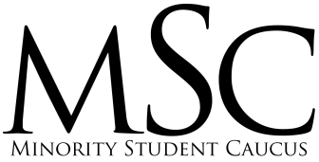

UNC Minority Health Conference  Call for Abstracts  http://www.minority.unc.edu/sph/minconf/2010/ | UNC Minority Health Conference  Call for Poster Abstracts  http://www.minority.unc.edu/sph/minconf/2010/ | UNC Minority Health Conference  Call for Poster Abstracts  http://www.minority.unc.edu/sph/minconf/2010/ | UNC Minority Health Conference  Call for Poster Abstracts  http://www.minority.unc.edu/sph/minconf/2010/ | UNC Minority Health Conference  Call for Poster Abstracts  http://www.minority.unc.edu/sph/minconf/2010/ | UNC Minority Health Conference  Call for Poster Abstracts  http://www.minority.unc.edu/sph/minconf/2010/ | UNC Minority Health Conference  Call for Poster Abstracts  http://www.minority.unc.edu/sph/minconf/2010/ | UNC Minority Health Conference  Call for Poster Abstracts  http://www.minority.unc.edu/sph/minconf/2010/ | UNC Minority Health Conference  Call for Poster Abstracts  http://www.minority.unc.edu/sph/minconf/2010/ | UNC Minority Health Conference  Call for Poster Abstracts  http://www.minority.unc.edu/sph/minconf/2010/

